Kem Chan
CS 405 – Secure Coding
Sept 12, 2026
Assignment 2 – Buffer Overflow Coding

Screenshot of code
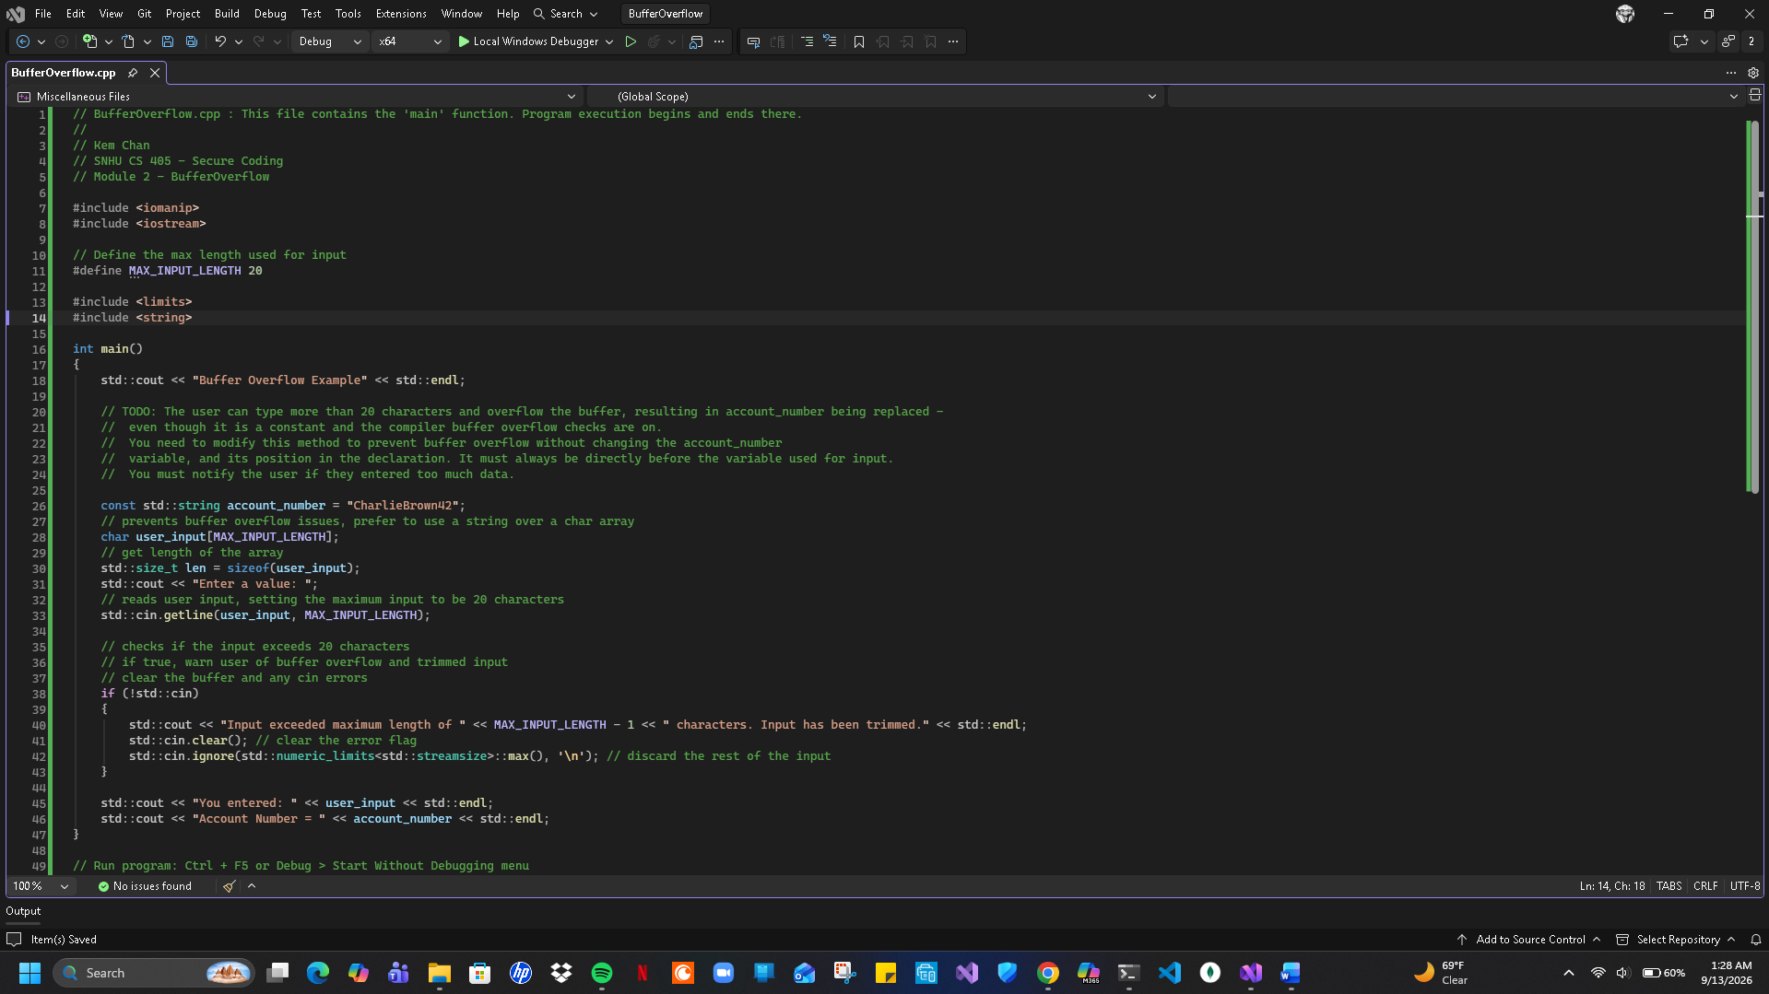

Screenshot of output
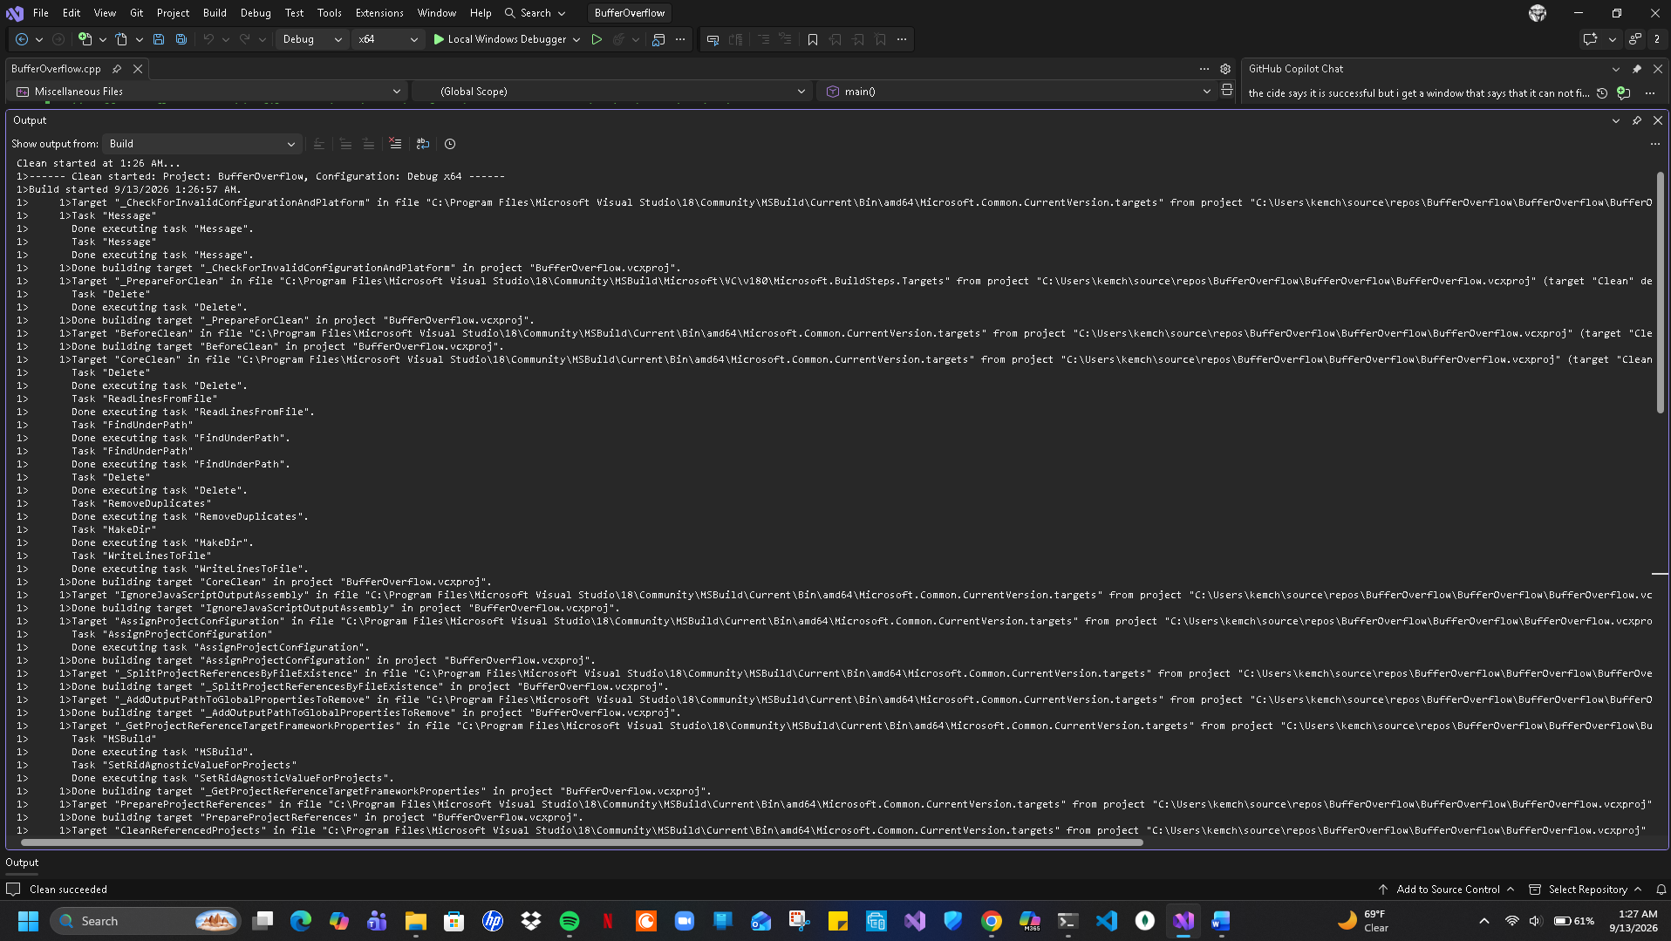
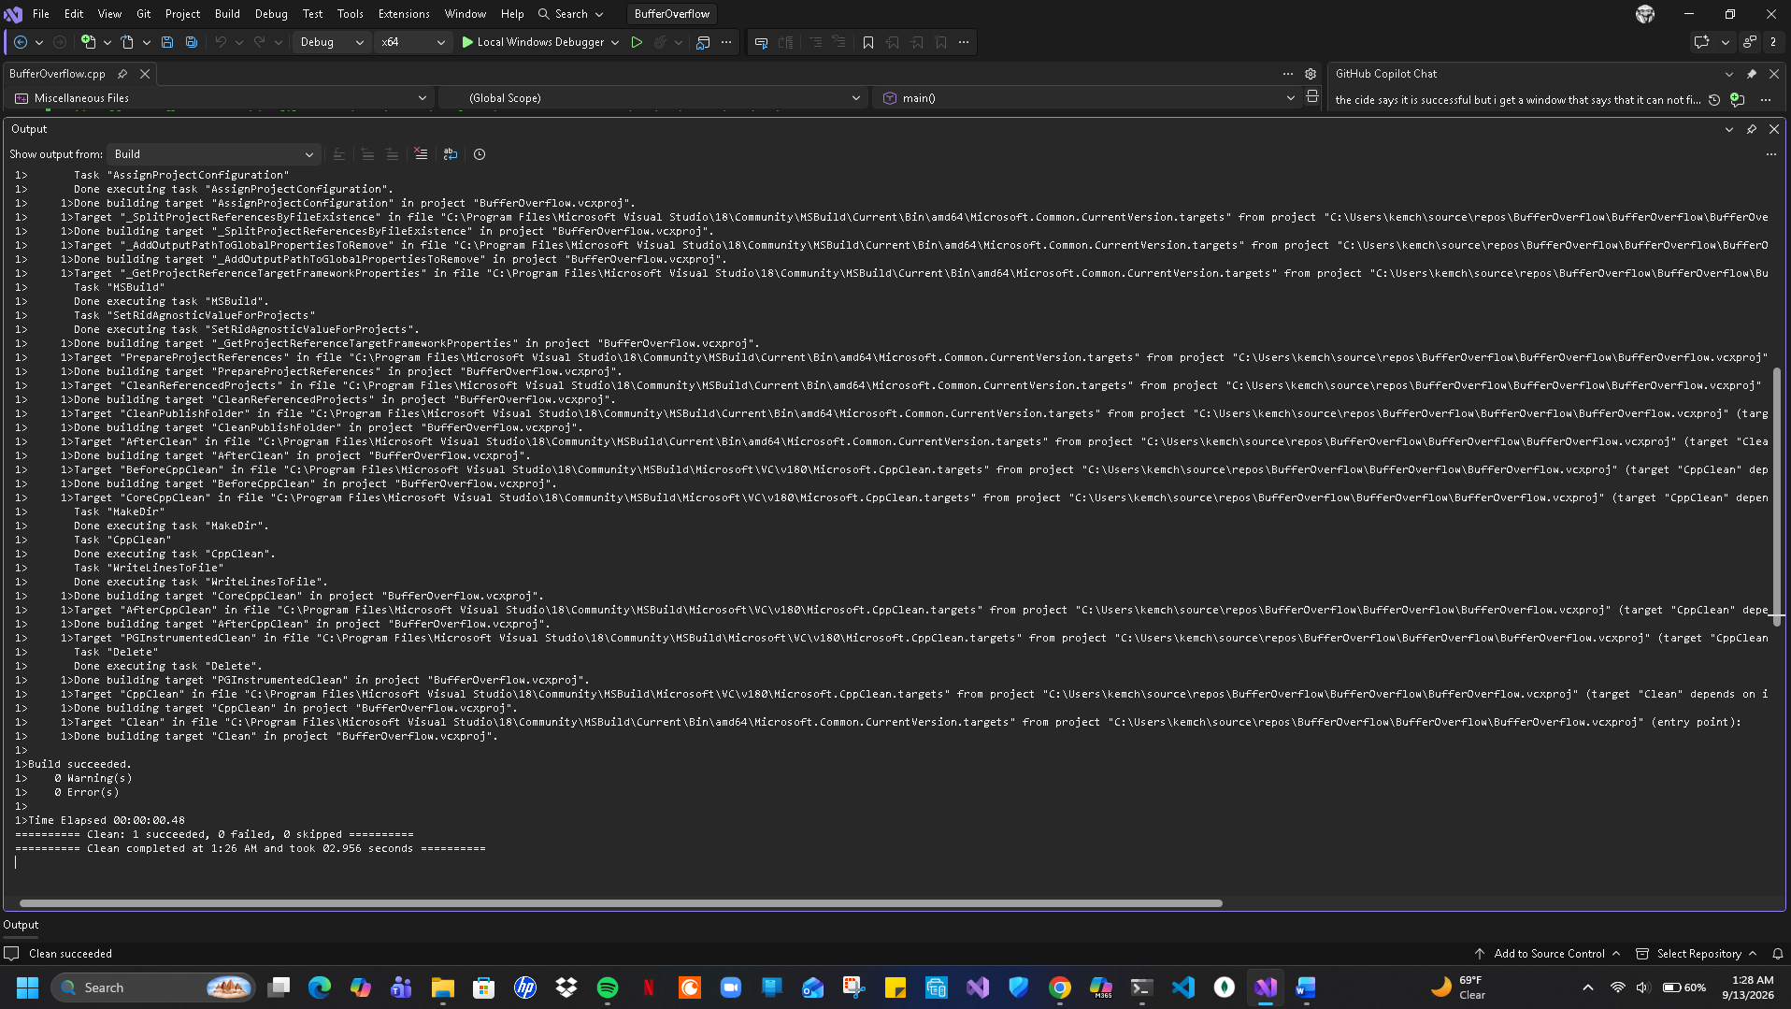

Summary
Looking at this assignment with the code provided to collect a number from the user and then display that number as well as a secret account. However, inputting too many characters will trigger the overwrite of the account so to prevent the user input impacting the account number I implemented a maximum length on the input that was hard coded into the software which could be adjusted as needed later. The approach I took for this assignment was implementing a hard limit to ensure that the stream drops any text that would be longer than 20 characters. While doing this it would also put in a state and buffer manager that would default to reset error flags and remove any trailing characters as well as truncating characters that were left hanging in the system input stream.

